E- Waste Survey Analysis

Table of Contents

1. About
2. Objective
3. How I conducted the survey
4. Observations
5. Number of Responses
6. Date of Last Response
7. Detailed Analysis of Each Question
8. Conclusion

About

Electronic waste or e-waste describes discarded electrical or electronic devices. Used electronics that are destined for refurbishment, reuse, resale, salvage recycling through material recovery, or disposal are also considered e-waste.

This E- waste survey was conducted in the month of May in 2021. During that time majority of India was in lockdown because of the second wave of the Coronavirus pandemic. Due to the fact that everyone was stuck at home schools, colleges, companies- all went online. Therefore, there was an increase in the number of electronic devices purchased around the world. I was curious to know what happened to old phones, laptops, televisions etc. after they stopped working. I conducted research and found out that people either stored them, or sold them to shops. After gaining this information I was still dissatisfied, and I wanted to know what happened to electronic waste after this. I went on the Internet to find the answers to all my questions. I soon established that Electronic waste was still quite new to our world, and people had not heard of it before the 1980’s. I learned about various recycling centers situated where I lived. Nowadays, people have heard of E- waste, but majority of the people are still not completely aware about how and why it is extremely harmful to our environment. I wanted to see what people’s basic awareness about Electronic waste and its disposal was, so I conducted a survey. I received over 100 responses from numerous people, in different countries. India, United States of America, England, Nepal, Spain, Singapore, Canada, France, New Zealand, Netherlands, Germany, Austria, South Africa, Wales and Puerto Rico – are some of the countries from where I received responses. Seeing what people’s awareness on E- waste is and how it is different for each country was truly enlightening.

Objective

The object of this E- Waste survey was for me to gain an understanding of how aware people were about Electronic Waste Management and to help anyone who was interested in learning new ways to recycle their electronics.

How I conducted the survey

I conducted this survey online due to the worldwide Corona virus pandemic. I used Google Forms, which proved to be an excellent software to conduct this survey. Ideally, I would have preferred to interview people and speak to them face-to-face, which I feel would have helped me gain a better understanding. However, conducting an online survey had its many advantages. I was able to reach a larger audience, and the responses to survey came from all over the globe.

Even though I could not interview everyone I desired to, I was still able interview a few people. I got in touch with someone who was involved in the environmental sector, Ms. Mallika Arya. She helped me gain a fresh perspective on E-waste, and environmentalism in general. It was very exhilarating to be interacting and learning from someone who works in the environmental field. I also gave people the option of giving me their email addresses so that I could write back and help someone out if they had any doubts or questions. Quite a few people got in touch with me and asked for advice. It was truly inspiring to see people wanting to learn more about Electronic Waste Management which is a major problem in today’s world.

Observations

I made numerous observations through this E- Waste Management Survey. Electronic Waste is still new to the world but I was surprised when I learnt that 23.6% of the people who gave the survey were completely unaware of E-Waste Management. Even in the remaining 76.4% of people who were aware of E-Waste Management, there are quite a few who did not know anything about it other than the fact that it should be recycled and is harmful for the environment. These results are good as it shows that people know the basics about E-Waste but I still feel as though there is a lot more people should be educated on about.

One of the more astonishing results I saw was that only 50.9% people actually recycled their electronic waste. More than 40% people had never recycled their E-Waste. This truly shocked and disappointed me. It also proved once again that more education on E-Waste is definitely required.

One of the questions I asked in the survey was “When did you begin to recycle your E-Waste?” I observed that majority of the people only began to recycle their E-Waste in 2016. That is merely 4 years ago. “What do you do with old working electronics that you no longer use?” was another question in the survey. The reason I asked this question was because even after rigorously researching I still felt as though there were more ways the average person recycled E-Waste. There were many different responses and as I hoped I learnt a lot of new ways in which people recycle their electronic waste.

56.6% people purchase 2 electronics annually. Whereas 22.6% of the people purchase up to 5 electronics every year. This meant that 21.8% of the people bought more than 5 electronic devices every year. The total number of new electronics purchased annually was unimaginable. The responses to this particular question were astounding.

More than 46% of people who replied to the survey said they do not take electronic recycling possibilities into consideration when buying a product. I strongly feel that in electronic buying shops the salespeople and show-owners must tell all customers about the electronic recycling of each product. I feel as thought this would increase awareness of E-Waste problems.

Number of Responses

The total number of responses in the Electronic Waste Management survey was 106.

Date of Last Response

The date of the last response in the Electronic Waste Management was 28th November 2020.

Analysis of Each Question

Q1. Name (Optional)

Q2. Gender (Optional)

The reason for asking people their gender was so I could find out if gender played even a minor role in awareness of Electronic Waste Management. The conclusion was that I could not find anything that could relate the gender of a person to their awareness on Electronic Waste Management.

Q3. Country

This question helped me to making a few observations. I was surprised to learn the majority of the people who reside in the United States of America, Singapore and India are unaware about E-Waste.

Q4. Are you aware about Electrical Waste Management?

This question was essential to the survey. I used the responses from this question to make many other observations. 76.4% of the people in the survey answered yes to this question. I feel as though this number must increase tremendously. Even if one is not aware about how to go about E-Waste recycling or the specific details, I feel everyone should know about the basics. I have gotten back to every one of the people (who gave me their email addresses) who wrote “No” in response to this question, and gave them information and advice regarding electronic waste.

Q5. What do you know about E-Waste?

Following up the first question this sees how much a person knows about E-Waste. This question actually taught me a lot. People wrote up to 3-5 lines for their responses and I learnt some interesting new facts about E-Waste. Some people had a wrong idea of what E-Waste is and I helped them gain an understating of E-Waste and how harmful it is to the environment.

Q6. Do you recycle your E-Waste?

This question was very cardinal question in the survey. According to me, there is a vast difference between knowing what E-Waste is and actually recycling your own electronic waste. I was shocked to learn that only 50.9% people actually recycled their E-Waste. Considering that 76.4% people were aware about Electronic Waste, the fact that only 50.9% did the recycling was very disappointing. 8.5% of the people said they recycle their E-Waste sometimes. This is a serious problem and should be taken care of. For example, I reside in a condominium in DLF Golf Links, Gurugram, Haryana, India where all kinds of waste management is taken very seriously. For E-Waste in particular there are drives, which take place often. I truly think that all neighborhoods should have E-Waste drives as it would greatly benefit the environment and make it easier for households to recycle their electronic waste.

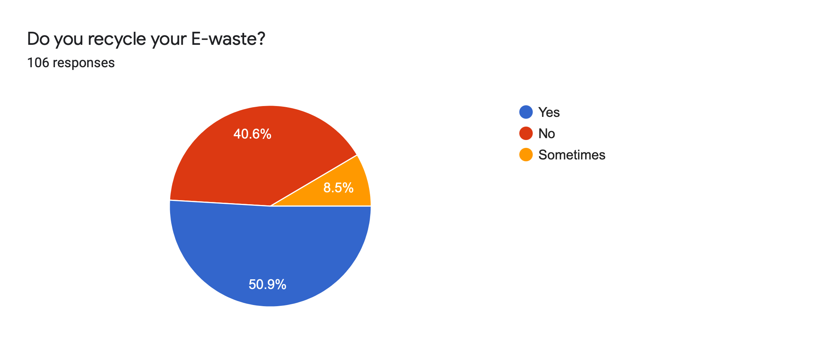

Q7. When did you begin to recycle your E-Waste?

This was another requisite question for the survey. It informed me as to when the majority of people started recycling their electronic waste. It was extremely shocking to learn that 37.7% of the people still do not recycle their E-waste. Even though 76.4% of the people in the survey knew about Electronic waste and its harmful effects, only 62.3% actually recycled their waste. This also goes to show that despite people being aware about E-waste, many of them are unable to do so or do not know how to go about it.

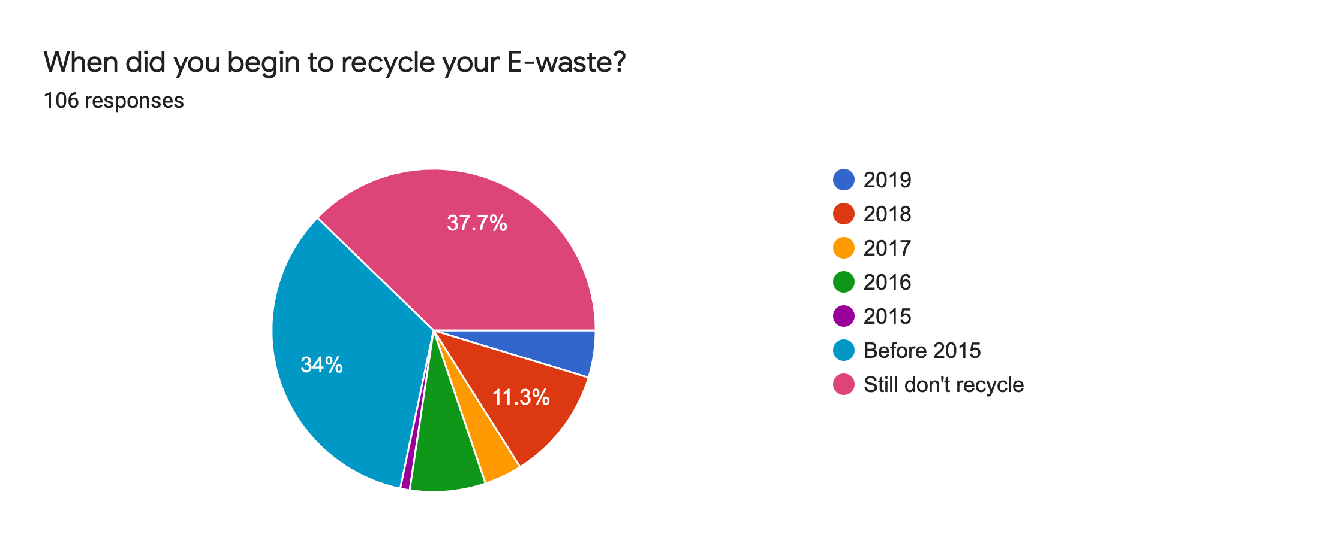

Q8. What do you do with old working electronics that you no longer use?

This question also proved to be vital for the survey. I learned that there were various effective ways for recycling electronic waste. Majority of the people either gave their used electronics to other family members or friends or sell them as second-hand. I came across numerous new and innovative ways of recycling. I also came to know that recycling of E-waste can vary from person to person, as in not everyone would recycle their waste in the exact same way, and recycling of electronic waste can also vary from location to location.

Q9. How many electronics do you purchase a year?

This question was an essential part of the analysis of the survey. Several calculations varied depending on how many electronics each person purchased annually. I also learnt that 56.6% of the people in the survey purchased 1 to 2 electronics each year, which was an adequate amount. I was a bit astonished to learn that 3.8% of the people actually purchase more than 10 electronics annually.

Q10. When you buy an electronic product do you consider the recycling possibility?

This was another key question to the survey. 53.3% of the people said yes, while the remining 46.7% said no. This showed that people need to be made more aware about the recycling possibility of various electronics, and needed to learn to start considering it before buying any electronics.

Q11. Do you think E-waste which is not recycled harms the environment?

This was the concluding question, which was aimed to see who all knew about the harmful effects of electronic waste to the environment. There were 93.4% of the people who said yes. However, 4.7% of the people who said maybe and 1.9% said no. Eventually, this 6.6% of the people need to learn that electronic waste is extremely harmful to the environment. Everyone must first realise that e-waste is causing great amounts of pollution.